Adaptive Spreading Factor (SF) Selection
Table of Contents
1. Research Topic 2
2. Abstract 2
3. Introduction 2
4. Background / Theory 3
5. Methodology / Modeling 4
5.1 LoRa PHY Simulation Platform 4
5.2 Parameter Definitions 5
5.3 PER Metric 5
5.4 Fixed-SF Baseline Curves 5
5.5 Adaptive SF Strategy — Code Explanation (MATLAB Implementation) 6
5.6 Initialization and Common Simulation Settings 6
5.7 Fixed-SF Baseline PER Curves 6
5.8 PER Curve Smoothing (Threshold Stability) 6
5.9 Reliability Threshold and Automatic Switching Points 7
5.10 Adaptive PER Construction and SF Selection 8
5.11 Visualization 9
5.11.1 Fixed SF vs Adaptive SF (PER vs SNR) 9
5.11.2 Selected SF vs SNR 9
5.12 Fixed-SF PER Simulation Function (run_one_sf) 9
5.12.1 Packetization and Symbol Generation 9
5.12.2 Chirp Generation 9
5.12.3 AWGN Injection and Non-Coherent Detection 9
5.12.4 PER Computation 10
6. Results 10
6.1 Fixed SF Performance Behaviour 10
6.2 Automatic Threshold Detection 11
6.3 Adaptive PER Curve Interpretation 12
6.4 Selected SF Behavior 12
6.5 Performance Gains Over Fixed SF 13
6.6 Observed Small PER Fluctuations 13
7. Discussion 13
8. Limitations and Future Extensions 14
9. Conclusion 14

1. Research Topic
This study focuses on the development and evaluation of an adaptive spreading factor (SF) selection mechanism for LoRa communication systems based on signal-to-noise ratio (SNR). The primary objective is to improve link reliability while maintaining efficient data transmission by dynamically selecting the most suitable SF under varying channel conditions.
The research investigates the relationship between SNR and packet error rate (PER) for different SF configurations and utilizes this relationship to derive switching thresholds for adaptive SF selection. A MATLAB-based physical layer simulation is employed to model LoRa modulation, transmission over an additive white Gaussian noise (AWGN) channel, and non-coherent detection at the receiver.
By comparing fixed-SF performance with the proposed adaptive approach, the study aims to demonstrate how adaptive SF selection can achieve a balance between communication reliability and spectral efficiency. The work also explores the practical implications of threshold-based adaptation and its effectiveness in improving overall system performance.

2. Abstract
This paper presents an SNR-based adaptive spreading factor (SF) selection method for LoRa communication systems, aiming to improve link reliability while maintaining transmission efficiency. In conventional LoRa systems, a fixed SF is often used regardless of channel conditions, leading to either unnecessary loss of data rate or reduced reliability. To address this limitation, this study proposes a threshold-based adaptive SF mechanism that dynamically selects the most appropriate SF according to the channel quality.
A MATLAB-based physical layer simulation is developed to evaluate the performance of different SF configurations (SF7, SF9, SF12) under additive white Gaussian noise (AWGN) conditions. Packet error rate (PER) is used as the primary performance metric. Based on the PER versus SNR characteristics, switching thresholds are automatically determined to ensure a predefined reliability requirement.
The adaptive SF strategy is constructed by selecting the lowest SF that satisfies the PER constraint at each SNR level. Simulation results show that the proposed method achieves the robustness of higher SFs in low SNR regions while benefiting from the higher data rates of lower SFs at improved channel conditions. This approach demonstrates a clear performance advantage over fixed-SF configurations by effectively balancing reliability and spectral efficiency.

3. Introduction
Low Power Wide Area Network (LPWAN) technologies have gained significant attention in recent years due to their ability to support long-range communication with low energy consumption. Among these technologies, LoRa has emerged as a widely adopted solution for Internet of Things (IoT) applications such as smart cities, environmental monitoring, and industrial systems. One of the key features of LoRa modulation is the use of different spreading factors (SFs), which directly influence communication range, robustness, and data rate.
The spreading factor determines the symbol duration and processing gain of the transmitted signal. Higher SF values provide improved resistance to noise and allow successful communication at lower signal-to-noise ratio (SNR) levels, but they also increase time-on-air and reduce data rate. In contrast, lower SF values enable higher data rates but require better channel conditions to maintain reliable communication. Therefore, selecting an appropriate SF is critical for achieving an optimal balance between reliability and efficiency.
In many practical implementations, a fixed SF is used regardless of channel variations. However, this approach is inefficient because channel conditions can change significantly over time and across different devices. Using a high SF in good channel conditions leads to unnecessary reduction in throughput, while using a low SF in poor conditions increases packet loss. This trade-off highlights the need for adaptive mechanisms that can dynamically adjust SF based on channel quality.
This paper proposes an SNR-based adaptive spreading factor selection method that aims to maintain a predefined reliability level while maximizing transmission efficiency. The approach relies on packet error rate (PER) performance obtained from physical layer simulations to determine switching thresholds between different SF values. A MATLAB-based simulation framework is used to model LoRa communication under additive white Gaussian noise (AWGN) conditions and to evaluate the effectiveness of the proposed method.
The main contribution of this work is the implementation of a threshold-based adaptive SF strategy that selects the minimum SF satisfying a target PER requirement. The proposed method is evaluated by comparing its performance with fixed-SF configurations, demonstrating its ability to improve overall system performance by balancing reliability and spectral efficiency.

4. Background / Theory
LoRa communication is based on chirp spread spectrum (CSS) modulation, which enables robust long-range transmission under low power conditions. A key parameter in LoRa systems is the spreading factor (SF), which defines the number of chips used to represent a symbol. The spreading factor is typically selected from a set of discrete values (e.g., SF7 to SF12), where each increment doubles the symbol duration and increases the processing gain.
The relationship between SF and system performance is fundamental. A higher SF results in longer symbol duration, which improves the receiver’s ability to distinguish the signal from noise. This leads to better performance at low signal-to-noise ratio (SNR) levels. However, this improvement comes at the cost of increased time-on-air and reduced data rate. Conversely, a lower SF provides higher data rates and lower latency but requires higher SNR to maintain reliable communication.
The reliability of a communication system can be quantified using the packet error rate (PER), which represents the probability that a transmitted packet is incorrectly received. PER is a function of both the modulation parameters and channel conditions. In general, for a given SF, PER decreases as SNR increases. Different SF values exhibit distinct PER versus SNR characteristics, where higher SFs achieve acceptable PER at lower SNR levels compared to lower SFs.
From a system design perspective, there is a trade-off between reliability and efficiency. Selecting a high SF ensures reliable communication under poor channel conditions but reduces throughput and increases energy consumption per transmitted bit. On the other hand, selecting a low SF improves efficiency but may lead to high PER if the channel conditions are insufficient.
Adaptive spreading factor selection aims to address this trade-off by dynamically choosing the most suitable SF based on channel quality. The key idea is to select the lowest SF that satisfies a predefined reliability requirement, typically expressed as a PER threshold. This approach ensures that the system maintains acceptable reliability while maximizing data rate whenever possible.
In this work, channel quality is represented by SNR, and the PER performance for each SF is obtained through physical layer simulations. These performance curves form the basis for determining switching thresholds between different SF values, enabling the implementation of a threshold-based adaptive SF selection mechanism.

5. Methodology / Modeling
The adaptive SF module is implemented and evaluated using a MATLAB-based PHY-layer LoRa simulation. The simulation generates PER vs. SNR curves for multiple fixed SF values and then constructs an adaptive strategy based on these results.

5.1 LoRa PHY Simulation Platform
The adaptive spreading factor strategy was implemented and evaluated using a MATLAB-based LoRa physical layer simulator derived from the LoRaBERMatlab framework. The simulator models the LoRa chirp spread spectrum modulation, additive white Gaussian noise (AWGN) channel conditions, and non-coherent FFT-based symbol detection.
The LoRaBERMatlab environment provides symbol-level Monte Carlo simulation capability for estimating BER, SER, and PER performance across a configurable SNR range. In this work, the framework was adapted to focus on packet error rate (PER) evaluation under non-coherent detection, which aligns with system-level reliability analysis.
The simulation structure includes:
- Random symbol generation
- LoRa chirp modulation
- AWGN channel model
- FFT-based non-coherent demodulation
- Packet-level error evaluation
The simulator was modified to enable multi-SF evaluation (SF7, SF9, SF12) under identical channel conditions, allowing consistent comparison and construction of the adaptive SF mechanism.

5.2 Parameter Definitions
- SNR range: Discrete set of SNR points, typically $SNR∈[-30,30]$ dB with 1 dB step.
- Spreading factors tested: $SF∈\{7,9,12\}.$
- Packet structure: Packets consist $N_{m}$​ symbols per packet, and the simulation transmits $N_{s}$ symbols per run. The number of packets is $N=Ns​/Nm​$ .
- Channel model: AWGN (additive white Gaussian noise) for baseline evaluation.

5.3 PER Metric
PER is defined as the fraction of packets that contain at least one symbol error:
$$PER=\frac{packets with ≥1 error}{total packets}$$
This metric is chosen because the adaptive SF decision is intended to ensure packet-level reliability, which is the relevant performance indicator for higher-layer communication protocols.

5.4 Fixed-SF Baseline Curves
The first step of the method is to generate fixed-SF performance curves:
- For a given SF, random symbols are generated and modulated to a LoRa chirp signal.
- AWGN is added according to each SNR point.
- The receiver performs non-coherent detection via FFT-based peak selection.
- Symbol decisions are grouped into packets and PER is computed.
- The process is repeated for each SF value to obtain:
$${PER}_{SF7}\left(SNR\right)$$
$${PER}_{SF9}\left(SNR\right)$$
$${PER}_{SF12}\left(SNR\right)$$
These curves provide the empirical relationship between channel quality and packet reliability for each SF configuration.

5.5 Adaptive SF Strategy — Code Explanation (MATLAB Implementation)
This section explains the MATLAB implementation of the SNR-based adaptive spreading factor (SF) selection used to construct an adaptive PER curve from fixed-SF simulation results.
The fixed-SF PER curves used for adaptive threshold extraction were obtained using the LoRaBERMatlab-based simulation framework described in Chapter 3.

5.6 Initialization and Common Simulation Settings
- 1. clear; clc;
- 2. Ns = 3e4;
- 3. Nm = 1e2;
- 4. BW = 125e3;
- 5. SNR = -30:30;
- clear; clc; resets the MATLAB workspace and command window to avoid using stale variables.
- Ns is the total number of transmitted symbols used in the Monte-Carlo simulation.
- Nm is the number of symbols per packet; therefore the number of packets is (N = Ns/Nm).
- BW is the LoRa signal bandwidth.
- SNR is the discrete SNR axis (61 points) used for evaluation and plotting.

5.7 Fixed-SF Baseline PER Curves
1. [PER_SF7, SNR] = run_one_sf(7, Ns, Nm, BW, SNR);
2. [PER_SF9, ~ ] = run_one_sf(9, Ns, Nm, BW, SNR);
3. [PER_SF12, ~ ] = run_one_sf(12, Ns, Nm, BW, SNR);
The function run_one_sf() is executed three times to obtain baseline PER curves for:
- SF7 → PER_SF7(SNR)
- SF9 → PER_SF9(SNR)
- SF12 → PER_SF12(SNR)
All three calls use the same SNR vector and identical simulation parameters, ensuring a valid point-by-point comparison across SFs.
The tilde ~ is used to ignore the second returned output (the SNR vector), because the same SNR vector is already captured from the first call and reused.

5.8 PER Curve Smoothing (Threshold Stability)
1. s7 = smoothdata (PER_SF7, ‘gaussian', 5);
2. s9 = smoothdata (PER_SF9, ‘gaussian', 5);
3. s12 = smoothdata (PER_SF12, 'gaussian', 5);
The PER points are generated using random noise realizations; therefore, near the transition region the measured PER may show small fluctuations. Smoothing is applied to stabilize threshold extraction:
- Gaussian smoothing with window length 5 produces smoothed curves s7, s9, s12.
- Smoothing is only used for detecting the transition SNR points, not for the final PER plot (the final plot still uses raw PER arrays).

5.9 Reliability Threshold and Automatic Switching Points
1. thresh = 0.2;
2. SNR_SF7_ok = SNR(find(s7 < thresh, 1, 'first'));
3. SNR_SF9_ok = SNR(find(s9 < thresh, 1, 'first'));
A target reliability requirement is defined as:
$$PER≤τ$$
where thresh = 0.2 corresponds to $τ=0.2$
For each SF, the code finds the first SNR value (lowest SNR) at which the smoothed PER curve goes below the target:
- SNR_SF9_ok: the first SNR where SF9 becomes “acceptable” (PER < 0.2)
- SNR_SF7_ok: the first SNR where SF7 becomes “acceptable” (PER < 0.2)
These two points are then used as transition thresholds:
1. T1 = SNR_SF9_ok; % transition SF12 -> SF9
2. T2 = SNR_SF7_ok; % transition SF9 -> SF7
Interpretation:
- Below T1, SF9 does not meet the PER target → use SF12.
- Between T1 and T2, SF9 meets the target but SF7 does not → use SF9.
- Above T2, SF7 meets the target → use SF7.
This enforces the design rule: use the smallest SF that satisfies the PER constraint, improving throughput while maintaining reliability.

5.10 Adaptive PER Construction and SF Selection
1. PER_adapt = zeros (size (SNR));
2. SF_sel = zeros (size (SNR))
3. for i = 1: numel (SNR)
4. if SNR(i) < T1
5. PER_adapt(i) = PER_SF12(i); SF_sel(i) = 12;
6. elseif SNR(i) < T2
7. PER_adapt(i) = PER_SF9(i); SF_sel(i) = 9;
8. else
9. PER_adapt(i) = PER_SF7(i); SF_sel(i) = 7;
10. end
11. end
This loop generates:
- PER_adapt(i): the adaptive PER value at each SNR point
- SF_sel(i): the selected SF at each SNR point
The adaptive curve is not re-simulated from scratch; instead it is constructed by selecting the corresponding PER sample from the fixed-SF curves according to the switching rule.
Formally, for each discrete SNR point:
$$SF\left(SNR\right)=\left\{\begin{aligned}{PER}_{SF12}\left({SNR}_{i}\right), \\ {PER}_{SF9}\left({SNR}_{i}\right), \\ {PER}_{SF7}\left({SNR}_{i}\right)\end{aligned}\right. \begin{matrix}{SNR}_{i}<T_{1} \\ T_{1}≤{SNR}_{i}<T_{2} \\ {SNR}_{i}≥T_{2}\end{matrix}$$

5.11 Visualization

5.11.1 Fixed SF vs Adaptive SF (PER vs SNR)
1. plot (SNR, PER_SF7, ‘-o', ...);
2. plot (SNR, PER_SF9, ‘-s', ...);
3. plot (SNR, PER_SF12, '-d', ...);
4. plot (SNR, PER_adapt,'-k', 'LineWidth', 2, ...);
5. xline(T1,'--r',...);
6. xline(T2,'--b',...);
This plot compares the three fixed-SF baseline curves and the constructed adaptive curve on the same SNR axis. The vertical lines mark the switching thresholds T1 and T2.

5.11.2 Selected SF vs SNR
1. figure; stairs (SNR, SF_sel, 'LineWidth', 2);
This staircase plot explicitly shows which SF is used at each SNR. It provides a direct visual confirmation that the adaptive algorithm switches:
- SF12 → SF9 at T1
- SF9 → SF7 at T2

5.12 Fixed-SF PER Simulation Function (run_one_sf)
1. function [PER_AWGN, SNR] = run_one_sf(SF, Ns, Nm, BW, SNR)
This function performs the PHY simulation for one SF value under AWGN.

5.12.1 Packetization and Symbol Generation
1. N = Ns/Nm;
2. M = 2^SF;
3. x = randi(M,1, Ns) - 1;
- $M=2SF$ is the symbol alphabet size.
- x is a random symbol stream in [0, M-1].
- Total packets are (N = Ns/Nm).

5.12.2 Chirp Generation
1. upChirp = loramod(x, SF, BW, BW);
2. dnChirp = loramod(0, SF, BW, BW, -1);
3. signal = upChirp .* repmat (dnChirp, length(upChirp)/length(dnChirp), 1);
loramod () generates the LoRa chirp-modulated waveform.
The multiplication with a repeated downchirp corresponds to the standard LoRa dechirping step before FFT detection.

5.12.3 AWGN Injection and Non-Coherent Detection
1. sigma = 1./ 10.^(SNR(CtrSNR)./20);
2. n = sigma/sqrt (2). * (randn(M*Ns,1) + 1j*randn(M*Ns,1));
3. Rx1 = signal + n;
4.
5. [~, idx] = max (fft (reshape (Rx1, M, Ns)));
6. ynCoh1 = idx - 1;
Noise is generated as complex Gaussian (I/Q) with variance determined by SNR.
The receiver reshapes received samples into M × Ns, performs FFT, and selects the maximum bin index as the detected symbol (non-coherent detection).

5.12.4 PER Computation
1. PER_AWGN(CtrSNR) = sum(sum(abs(reshape(x,N,Nm) - reshape(ynCoh1,N,Nm)), 2) > 0) / N;
Symbols are reshaped into packets of length Nm.
A packet is counted as erroneous if any symbol differs.
PER is the fraction of erroneous packets.

6. Results
This section presents the performance evaluation of the proposed SNR-based Adaptive Spreading Factor (SF) mechanism and compares it against fixed-SF configurations (SF7, SF9, SF12). The analysis is based on packet error rate (PER) under AWGN channel conditions.

6.1 Fixed SF Performance Behavior
From the PER vs. SNR curves:
- SF12 operates reliably at very low SNR values (around −22 dB region).
- SF9 becomes reliable at moderate SNR levels (around −13 dB region).
- SF7 requires higher SNR values (around −8 dB region) to achieve low PER.
This behavior is expected due to LoRa modulation characteristics:
- Higher SF → longer symbol duration → higher processing gain → better noise robustness.
- Lower SF → shorter symbol duration → higher data rate but lower noise immunity.
Thus, fixed-SF operation creates a trade-off:
SF | Reliability at Low SNR | Throughput | Energy per Bit
SF12 | High | Low | High
SF9 | Medium | Medium | Medium
SF7 | Low (at low SNR) | High | Low
Using a single fixed SF across all SNR regions is therefore inefficient.

6.2 Automatic Threshold Detection
A PER constraint of:
$$PER<0.2$$
was selected as the target reliability requirement.
From the smoothed PER curves, two switching thresholds were automatically extracted:
- $T1 ≈ -13 dB$
Transition from SF12 to SF9.
- $T2 ≈ -7 dB$
Transition from SF9 to SF7.
These thresholds correspond to the first SNR points where the next lower SF satisfies the PER requirement.
This ensures that:
- The system never switches to a lower SF before it becomes reliable.
- The smallest possible SF that satisfies reliability is always selected.
As shown in Figure 6.1, the adaptive scheme follows SF12 in the low-SNR region, transitions to SF9 at T1 ≈ −13 dB, and finally switches to SF7 at T2 ≈ −7 dB.
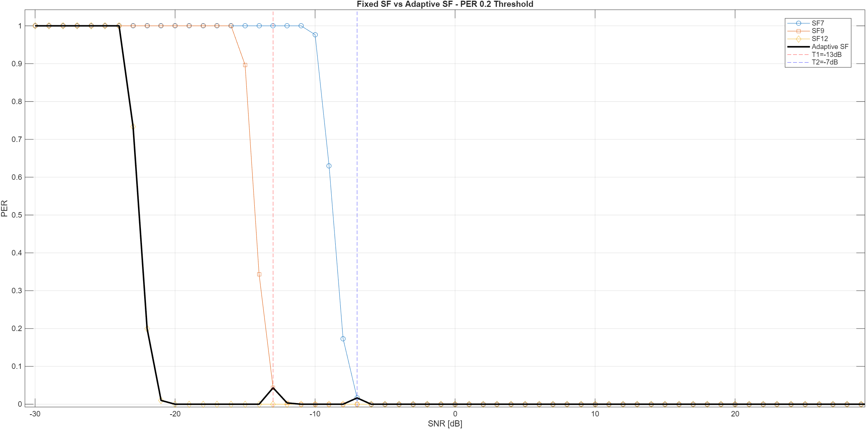
Figure 6.1: – PER vs SNR for Fixed and Adaptive SF (PER Threshold = 0.2)

6.3 Adaptive PER Curve Interpretation
The adaptive PER curve (black curve in the first figure) is constructed by selecting:
- SF12 when SNR < T1
- SF9 when T1 ≤ SNR < T2
- SF7 when SNR ≥ T2
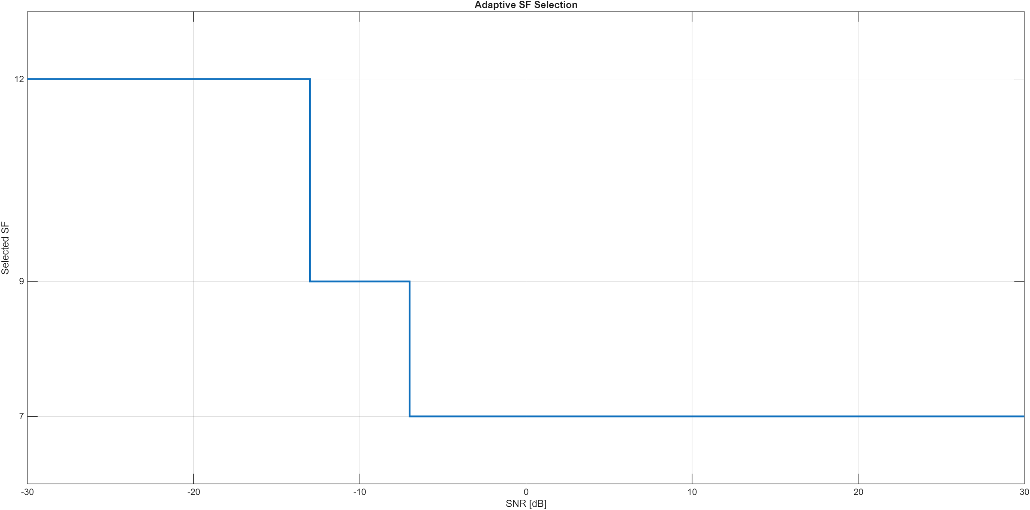
Figure 6.2: Adaptive SF Selection as a Function of SNR
Figure 6.2 illustrates the discrete switching behavior of the adaptive algorithm across the SNR range.
The resulting behavior shows:
- At very low SNR, adaptive performance matches SF12.
- In the mid-SNR region, performance transitions smoothly to SF9.
- At higher SNR values, adaptive performance follows SF7.
The adaptive curve therefore represents the envelope of reliable performance while maximizing efficiency.

6.4 Selected SF Behavior
The second figure (Adaptive SF Selection) clearly shows the switching logic:
- $SNR < -13 dB → SF12$
- $-13 dB ≤ SNR < -7 dB → SF9$
- $SNR ≥ -7 dB → SF7$
The staircase structure confirms correct implementation of threshold-based switching.
This behavior reflects practical LoRa adaptive data rate logic, but here it is derived directly from PHY-layer performance constraints.

6.5 Performance Gains Over Fixed SF
Compared to fixed-SF operation:

Compared to Fixed SF12
- Adaptive SF achieves identical reliability at low SNR.
- At higher SNR, it significantly increases throughput by switching to lower SF.

Compared to Fixed SF7
- Adaptive SF avoids the high PER region at low SNR.
- It prevents packet loss by switching to more robust SFs.
Thus, adaptive SF achieves:
- Reliability of the most robust SF when needed.
- Throughput efficiency of lower SF when channel conditions allow.

6.6 Observed Small PER Fluctuations
Minor spikes in the adaptive curve around switching boundaries are due to:
- Monte-Carlo randomness in PER estimation.
- Discrete SNR sampling (1 dB resolution).
- Packet-level error counting (binary packet success/failure).
These fluctuations do not indicate instability in the adaptive logic.
Increasing Ns (number of symbols) would further smooth the curves but at the cost of simulation time.

7. Discussion
The adaptive SF method provides a structured way to improve robustness at low SNR while maximizing efficiency at higher SNR. At very low SNR values, SF12 is selected to maintain packet delivery. As SNR improves, the method transitions to SF9 and finally to SF7, reducing time-on-air and increasing throughput.
Minor discontinuities in the adaptive PER curve can occur near switching thresholds due to finite Monte-Carlo sampling and discrete SNR resolution. Increasing the number of simulated symbols or applying smoothing reduces such artifacts.

8. Limitations and Future Extensions
The presented adaptive method is SNR-based and evaluated under AWGN conditions. Extensions may include:
- Interference-aware selection using SINR instead of SNR
- Joint adaptation of SF and coding rate (CR)
- Time-varying SNR models and mobility-aware adaptation
- Network-level evaluation including collisions and LoRaWAN ADR benchmarking

9. Conclusion
This work implemented an SNR-based adaptive SF selection mechanism in a MATLAB LoRa PHY simulation framework. The method uses fixed-SF PER curves to derive switching thresholds that satisfy a target PER, then constructs an adaptive PER curve reflecting dynamic SF selection. The results demonstrate that adaptive SF can maintain reliability under poor channel conditions while improving efficiency when channel quality allows lower SF operation.

